Blue Harvest
Game Design Documentation
By Kayne Ruse

<PICTURE>

Introduction 3
Marketing Information 3
References 3
Gallery 3
Storyline 4
Act 1 4
Act 2 4
Act 3 5
Side Quests 6
Mini Games 6
Notes 6
Game World 7
Game Mechanics 8
Player Controls 8
Game Objects 8
Game World Generation 8
Game Assets 9
Graphical Assets 9
Audio Assets 9
Screen Flow 10
Technical Details 11
Development Schedule 12
Preproduction 12
Prototyping 12
Alpha Stage 12
Beta Stage 12
Release 1.0 12
Release 2.0 12
Back Burner 12
Cancelled Content 12
To Do List 12
Notes 12
Post Mortem 13
Notes 14

Introduction
Blue Harvest <working title> is a dungeon crawler role playing game (RPG) where you take on the role of Brock, a boy who must save his little sister <working story>. The game is viewed in a three dimensional world from a fixed top down position, with pixel sprites used for characters, objects and enemies in the game world. A majority of the world consists of randomly generated dungeons with multiple floors, each floor built from a set of prefabricated meshes in a grid based pattern depending on the dungeon’s theme. The game world will also have a hub location which acts as a staging area for the player, a tutorial location available at the beginning of the game, and several other locations accessible from the hub.

Marketing Information
Blue Harvest <working title> is an open source, free dungeon crawler role playing computer video game, distributed through GitHub.com. The game’s development process will be publicly documented as the game progresses, with user feedback going towards and guiding the development of the game. The primary information and distribution channels for the game are the KR Studios development blog, and the GitHub.com git repository page.

References
https://github.com/Ratstail91/Project-RPG
http://ratstail91.tumblr.com/

Gallery
<Screenshots>
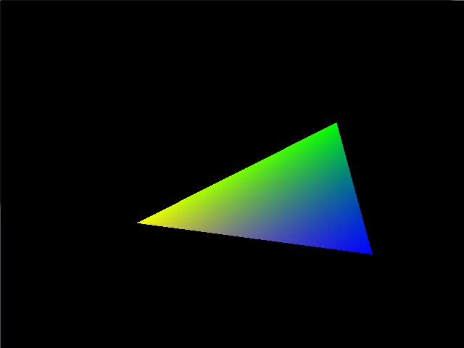

Storyline

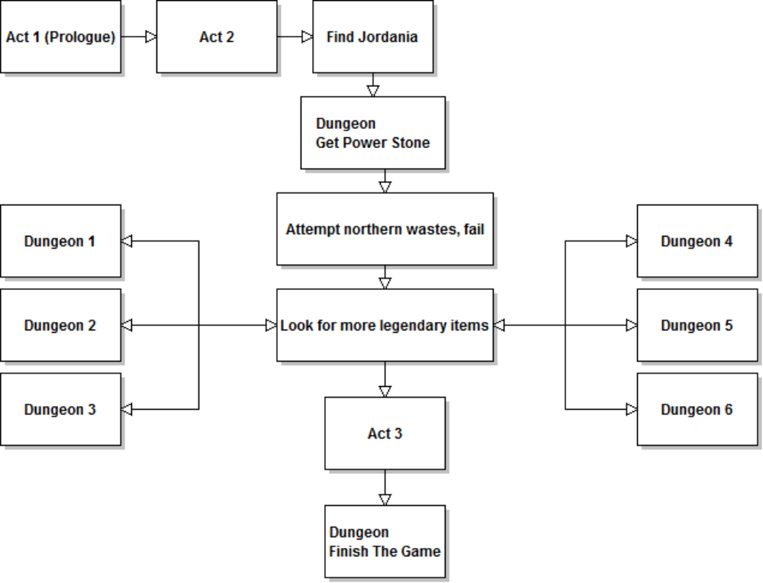

Act 1 is a basic setup, but also acts as a tutorial for the users with signposts detailing control systems, how to fight, etc. It also provides the premise for the adventure: rescue your sister. Act 2 will be the main part of the game, where the player can explore, learn and eventually roam free around the world, achieving each of the main story goals, and any of the side quest goals available. Act 3 will be available when the player has completed the main story goals. This will be the long goal of the game, but will be overall short but detailed, and will wrap up the game’s storylines. There is a split ending as noted below.

Act 1
Brock is a 12 year old boy who has a 10 year old little sister called Lucy. The two kids were playing near some old ruins one day, when suddenly, a monster appeared and kidnapped Lucy, taking her into the ruins. Since the two kids are alone besides each other, it is up to Brock to save her.

After defeating the enemies inside the ruins, Brock falls into a magic portal that transports him to another world.

Act 2
In the new world called Ivalice <working name>, Brock finds a town called Jordania <working name>, which acts as a hub for the greater part of the game. Here, the player can wander around, buy things at the markets, talk to NPCs for advice, and overall prepare for exploring the world.

After talking to a number of the NPCs in the town, the player learns that the monster that kidnapped his sister lives in the distant northern wastes <working concept>. One NPC, called Theodore <significant character, elderly, working name> approaches Brock to warn him about adventuring alone, and advises that he explore a dungeon to the south, which holds an item that will help him greatly on his quest.

After defeating said dungeon, Brock receives a power stone. This ups his attack power, and allows him to use magic. Using this magic, Brock gets deeper into the northern dungeon, but after confronting the final boss Leo, who he assumes kidnapped his sister, he is defeated and wakes up again in the town.

Brock is told by Theodore that other dungeons contain more power stones that can boost his strength. With this new information, Brock sets out to gather the stones and become stronger to save his sister. The player then progresses to each of the other dungeons in the world.

At this point, the player has free reign on most of the world, and can defeat each dungeon in any order he wants. However, some dungeons may be inaccessible without elements from elsewhere in the game. Also, there are bonus areas that cannot be unlocked without the abilities gained from another dungeon.

Act 3
When the player has defeated the basic necessary parts of the dungeons, the final dungeon will become available. Defeated similarly to the other dungeons, when the Brock reaches the final boss, he will confront Leo, and defeat him.

During the first stage of the fight, the player will fight Leo normally. When the player defeats Leo, Theodore appears, and attacks Leo. Failing the attack, it is revealed that both Leo and Theodore are immortal, and their immortality is linked.

Since all of the stones have been gathered by Brock, Leo absorbs Theodore’s power and immortality killing him and becoming even stronger, this being his apparent goal. This begins the second stage of the fight, and the player must defeat Leo in this super state.

When the second stage of the fight is complete (Leo does not die yet, but is severely weakened), Brock demands to know why his sister was taken, but Leo scoffs and states:

“That little girl was just a snack for a monster. If I hadn’t come across her in the wastes she’d be dead.”

With this revelation, Brock demands to see her, and Leo complies. Questioning if Theodore was just manipulating Brock for his own attempt to gain power, the player has a choice. Either run away with his sister, and let Leo live, or finish the fight and avenge Theodore’s death. This choice is intended to have the player ponder the final outcome of the game.

If the player decides to flee, the game ends, with Theodore shown commenting that he thought He could defeat Leo with the stones, but ultimately failed like an old fool. He is shown to be very bitter.

If the player decides to defeat Leo, the game ends, and shows Leo commenting that his old friend chose a great puppet. He also thanks Brock for ending their centuries old feud. He is shown to be content with the result of the game.

Side Quests
A side quest is a task within a video game that does not contribute to the main storyline, but can often provide bonuses that can assist the player in the main storyline’s quests. Side quests often allow the player to explore more of the game world, provide some back story for the game’s setting, and offer a distraction to the player when they become bored of the main storyline for a short time.

The game will have multiple side quests available.

<Text>

Mini Games
A mini game is a “game within a game”, often providing short term bonuses for successful play throughs, as well as short, optional distractions to the player. The gameplay of a mini game is usually simplistic in nature, often akin to an arcade game.

The game will have multiple mini games available.

<Text: Card game, mechanics like triple triad?>

<Text>

Notes
The split ending is intended to make the players think about the ending, and even have different views from other people who chose a different ending.

The only points in the above outline where the sister is mentioned are in the beginning and the end. This might make people simply not care about the sister, therefore special care must be taken when the storyline is fleshed out.

The side quests and mini games will be time consuming to the main development cycle, however these can be outsourced.

Game World
<Text>

Game Mechanics
<Text>

Player Controls
<Text>

Game Objects
<Text>

Game World Generation
<Text>

Character Levels, skills and abilities
<Text>

Game Assets
<Text>

Graphical Assets
<Text>

Audio Assets
<Text>

Screen Flow
<Diagram>

Technical Details
<Text>

Development Schedule
This game has no deadline or release date. However the development cycle must be kept in check to ensure that the game does not become vapourware. The Game Design Document must be kept up to date with any policy or development cycle changes.

Preproduction
Creation of Game Concept Document
Distribution channel established

Prototyping
OpenGL Prototype
Dungeon Generation Prototype
Gameplay Prototype
Statistics Prototype
<Text>

Alpha Stage
Movement within the game world
Combat within the game world
Placeholder assets
Placeholder plotline
Plotline implementation (dialog, scripts, etc)
<Text>

Beta Stage
<Text>

Release 1.0
<Text>

Release 2.0
<Text>

Back Burner
<Text>

Cancelled Content
A major component of the original concept what a “Magic: the Gathering” like mechanic acting as a large portion of the game. This has been rejected; however a simple card game mini game will be reintroduced later in the development cycle.

<Text>

To Do List
<Text>

Notes
<Text>

Post Mortem
<Text>

Notes
<Text>
These snippets must be moved to another location in the GDD.

//…
Magic is ranged, but consumes MP.
Magic cannot be used until the end of dungeon 2.

Character and Equipment Statistics

Level
Current HP, Max HP
Current MP, Max MP
Melee Attack, Melee Defence
Magic Attack, Magic Defence
Weapon, Armour

Combat Damage Equation

Dam = max ( C.Atk + C.Wpn – E.Def, 0 ) + ceil( C.Lvl / E.Lvl ) + k
E.CHP = E.CHP – (Dam – E.Amr/2) + k

C | This Character
E | Enemy Character
Dam | Damage value
CHP | Current HP
Atk | Attack
Def | Defence
Wpn | Weapon
Amr | Armour
Lvl | Level
k | Balance modifiers

Level Experience Equation

E = A(B^{C})

E | Experience needed for this level
A | Experience needed for level one
B | Ratio modifier expressed as a decimal
C | Current level

Read Later
http://tvtropes.org/pmwiki/pmwiki.php/Main/SpritePolygonMix
http://tvtropes.org/pmwiki/pmwiki.php/Main/NewGamePlus
http://tvtropes.org/pmwiki/pmwiki.php/Main/MonsterCompendium

